**Loan Application**

**Welcome Page:**

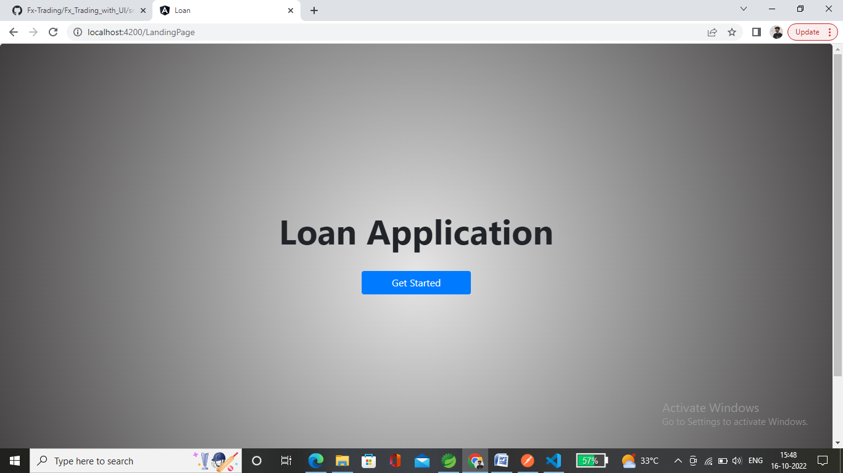

* Click on **Get Started** Button to enter Loan Application.

**Loan Application :**

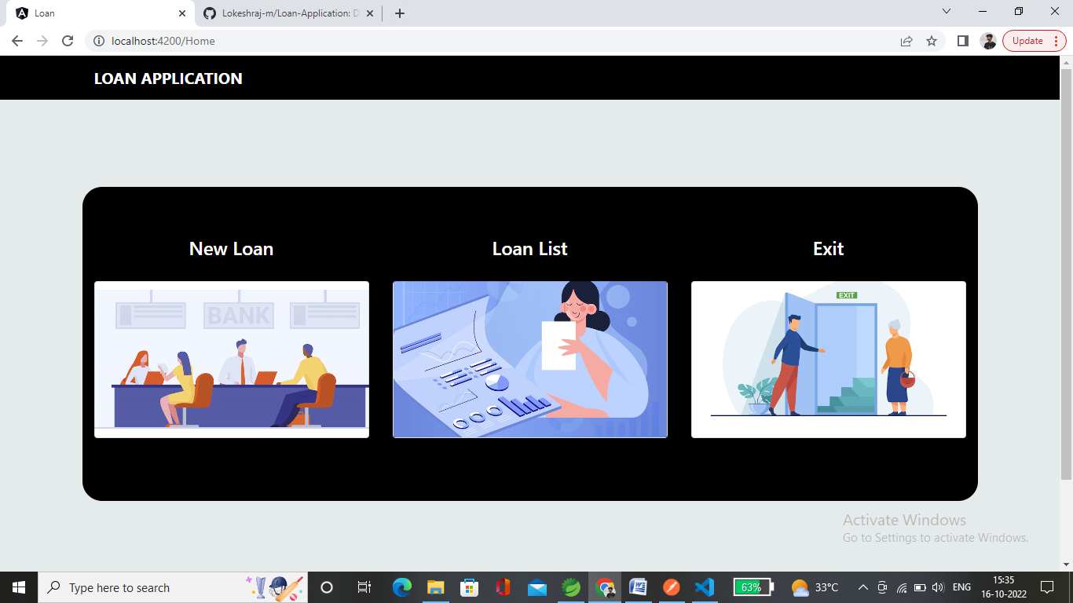

* Click on **New Loan** to create a loan for the customer.

**New Loan:**

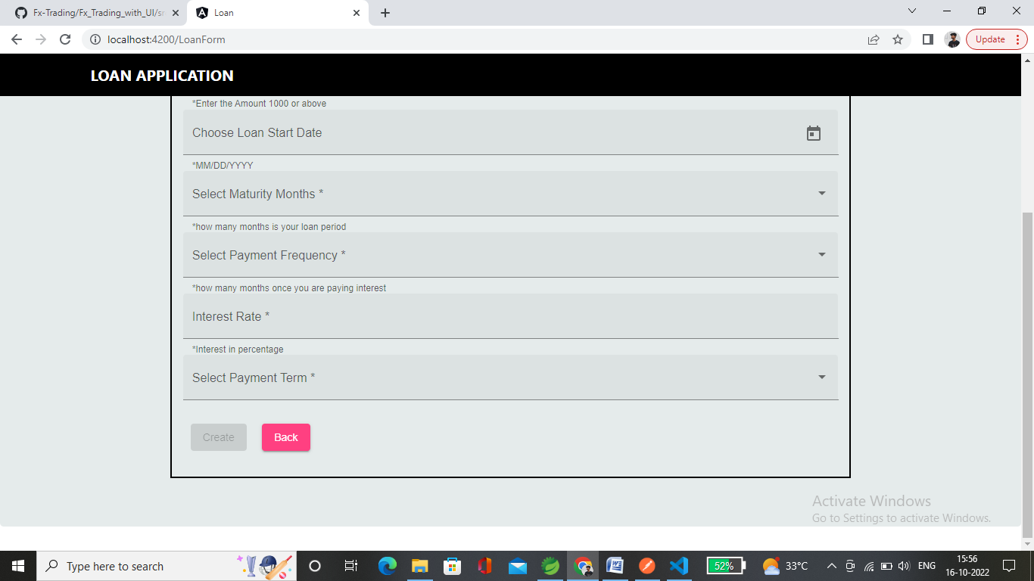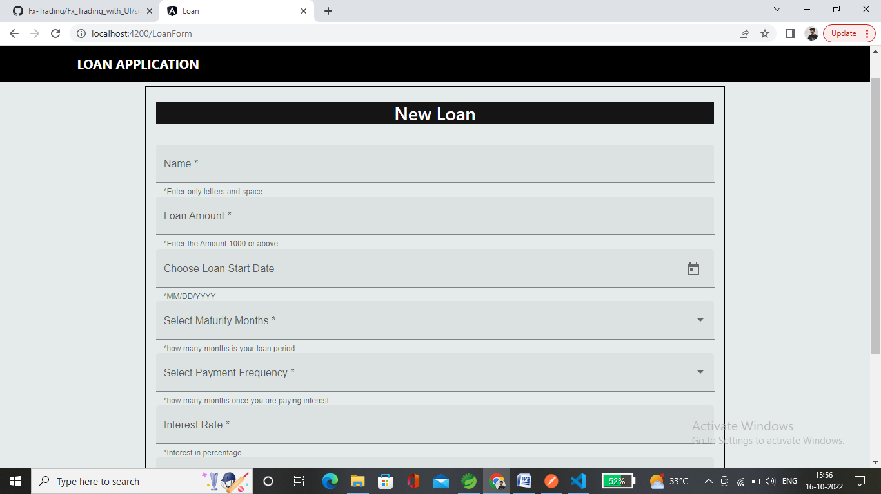

* To Create a Loan for the customer above details are required.

**Loan Form Validation:**

1. 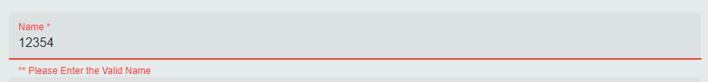**Name:** It should contain only letters and space in between two words. It should not contain any numbers and special Characters.

* 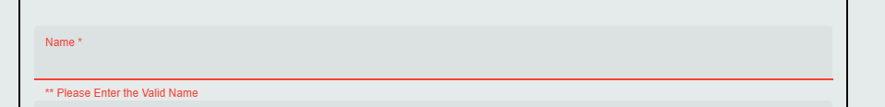Number cannot be applicable.
* Spaces cannot be applicable.

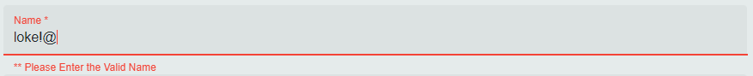

* Special characters not allowed.

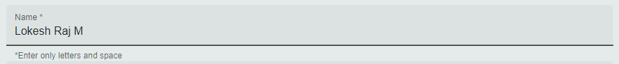

* **Correct** Name Format.

1. 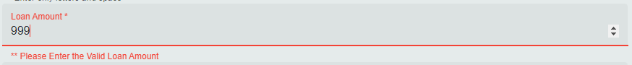**Loan Amount:** It should be above 1000 (it can be modified as per client requirement).

* Minimum amount is 1000.



* Minus amount not applicable.



* **Valid** Loan Amount.

1. 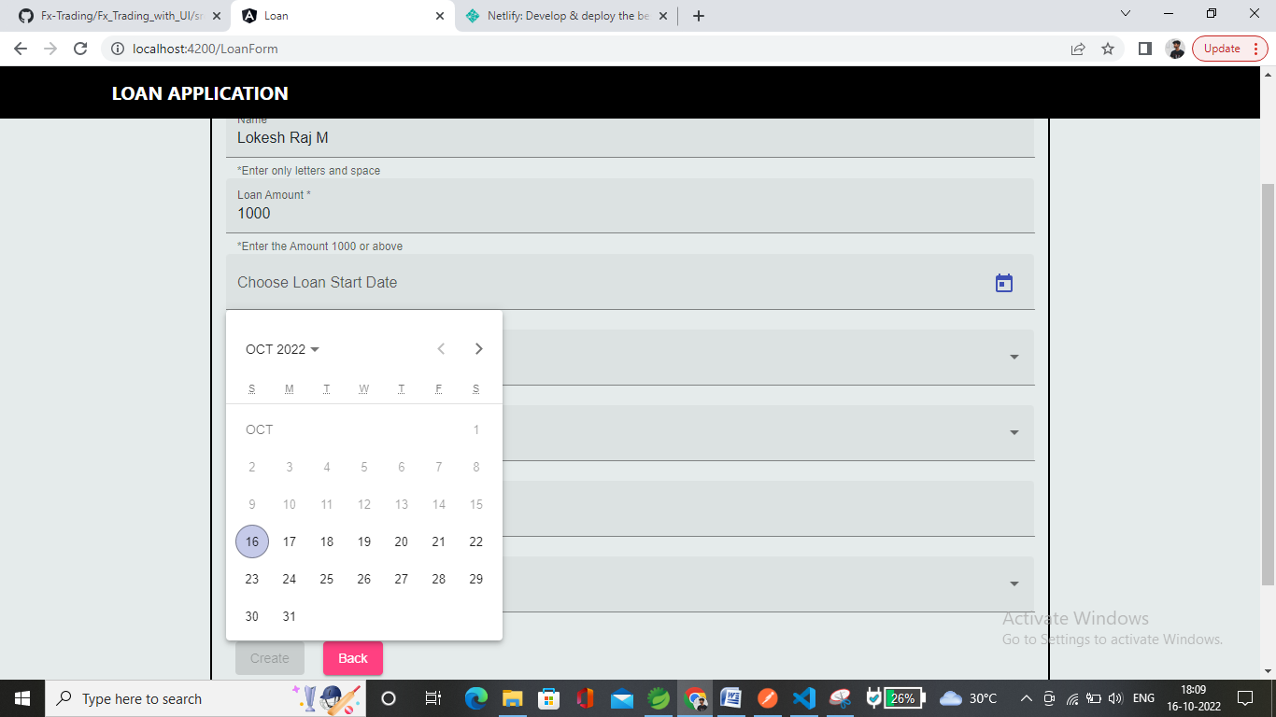**Loan Start Date:** only future date will visible previous date is disabled. For Assumption, I declared that the loan can start in next one year from the Trade Date. It can be modified as per client requirement.
2. **Maturity Months:** For Assumption, I declared the years in months as 12, 24, 36, 48, 60 months (Time Period of the Loan). It can be modified as per client requirement.

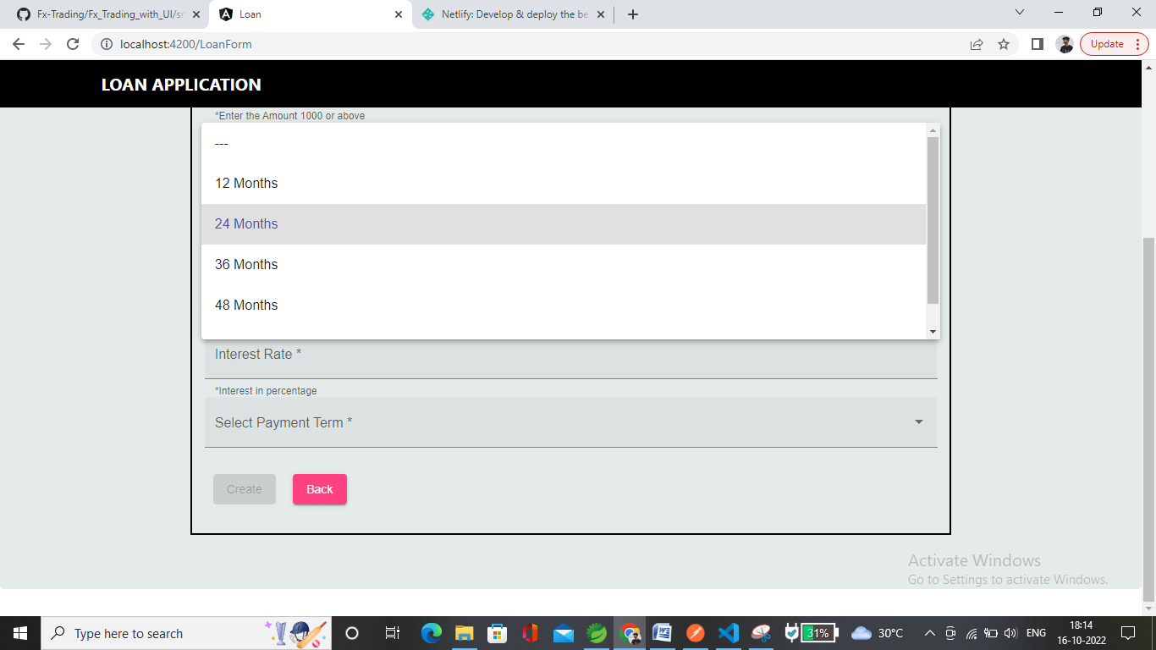

1. 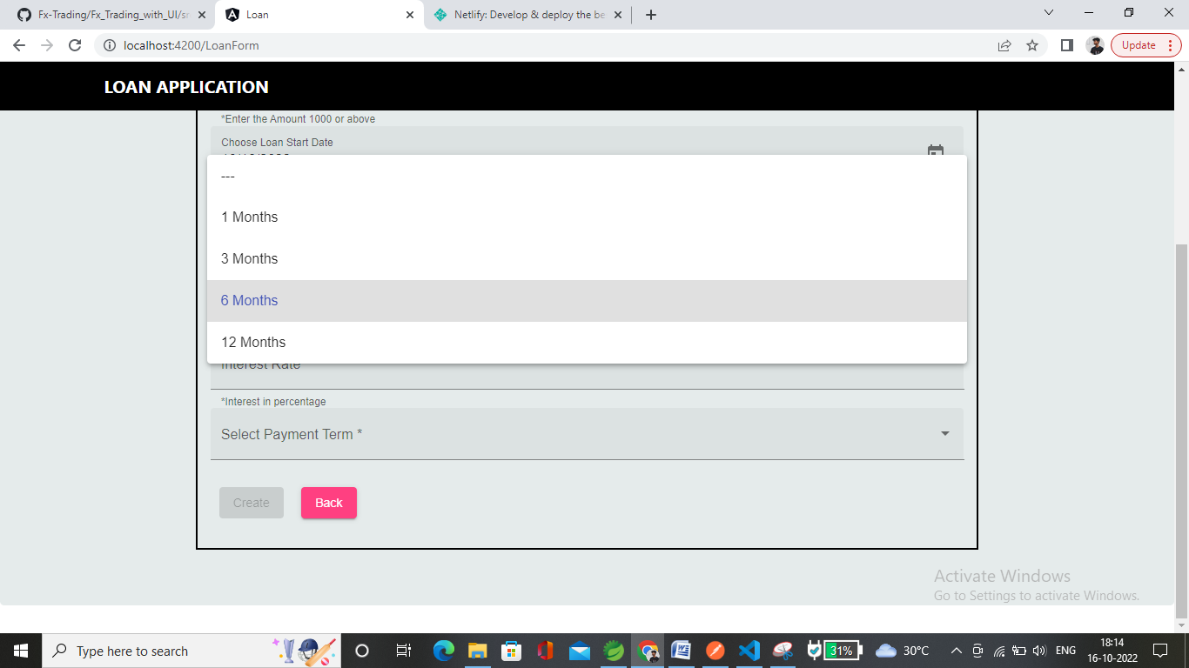**Payment Frequency:** Number of payments in a Year. Like 1, 3, 6, 12 month once.
2. **Interest Only:** It should be between 0 to 100 above that it displays Warning.

* Minus value is not applicable.
* **Valid** interest rate.

1. 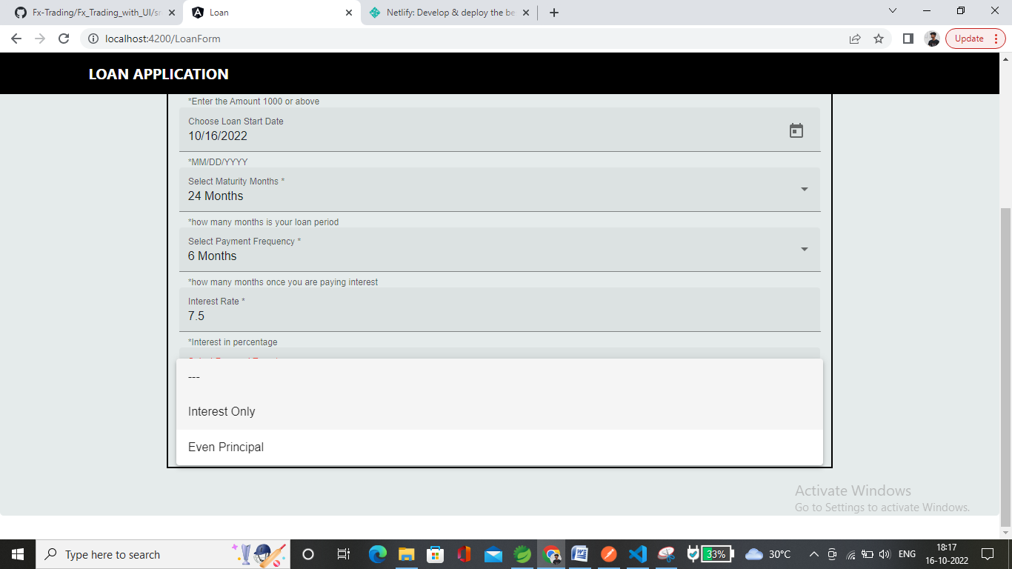**Payment Term:** It can be Interest only or Even Principal.

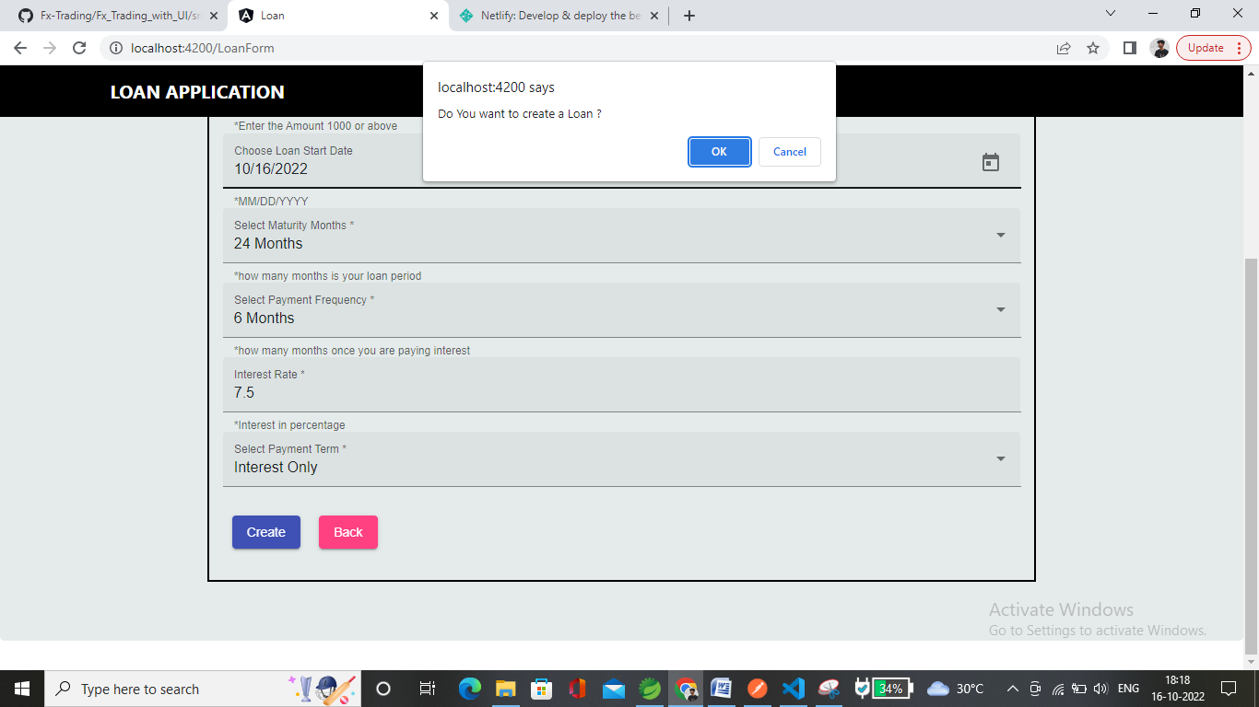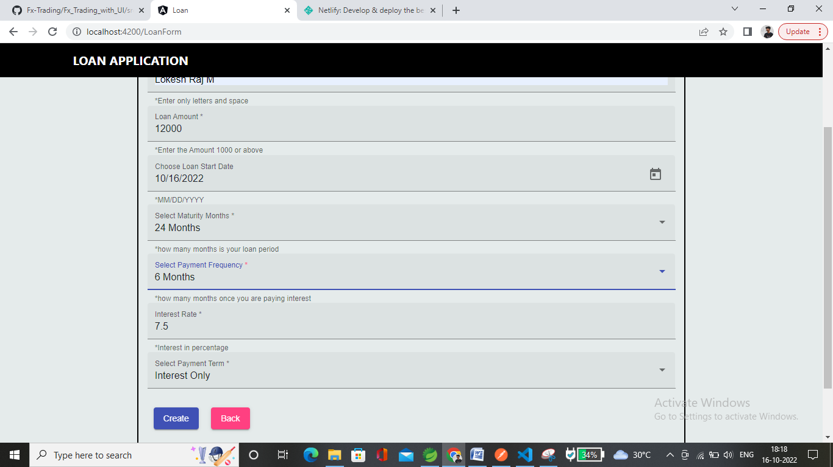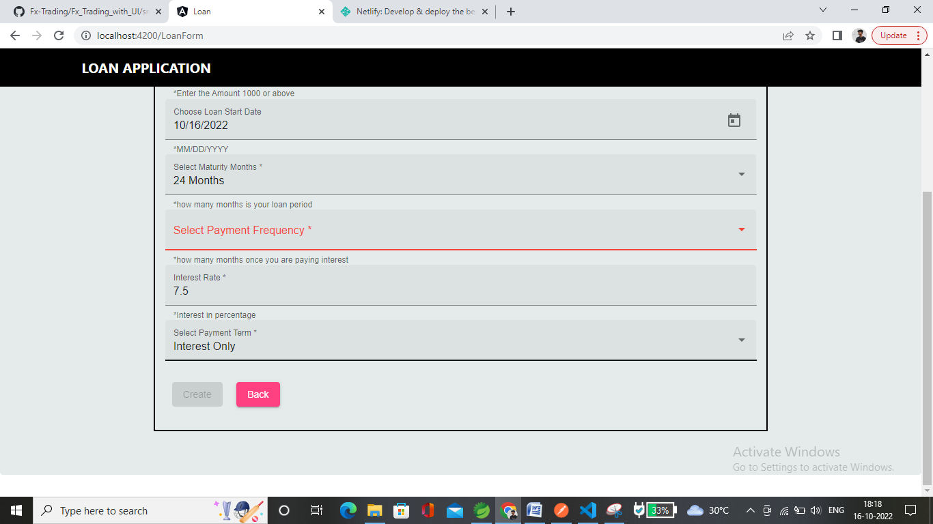

* After entering all details in correct requirement. The **submit** button will enable.

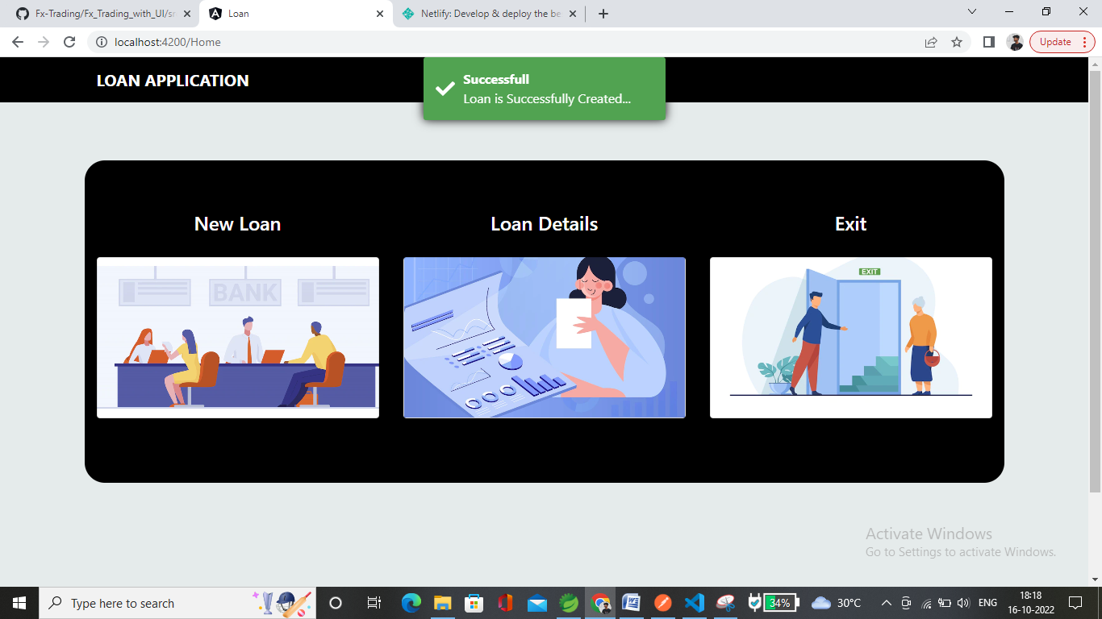

* Loan Created Successfully.

**Loan Details:**

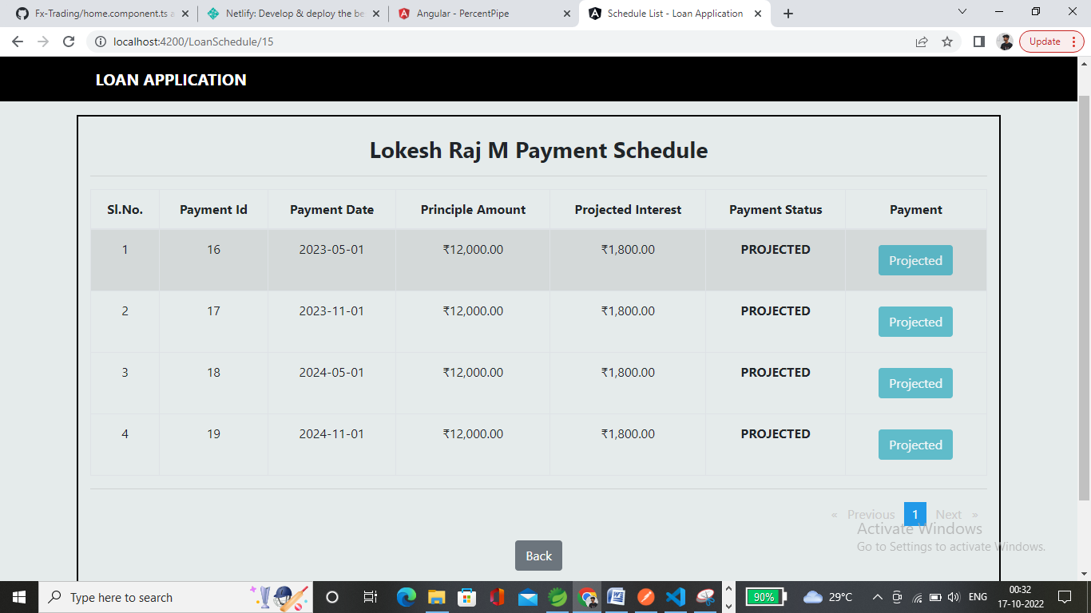

* Loan Details will list all customers loan.
* Click on particular customer to populate the Loan Schedules.

**Schedule Details:**

* Shows all payment Schedules for the particular Customer.
* 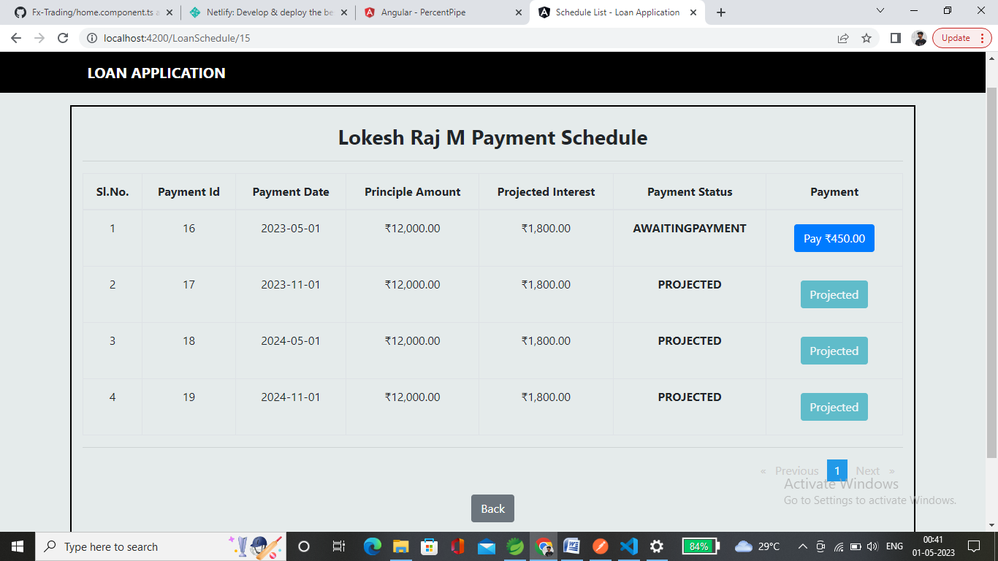Initially the payment status is projected.

**Payment:**

* When the current date is payment date the payable amount will populate with the Amount.

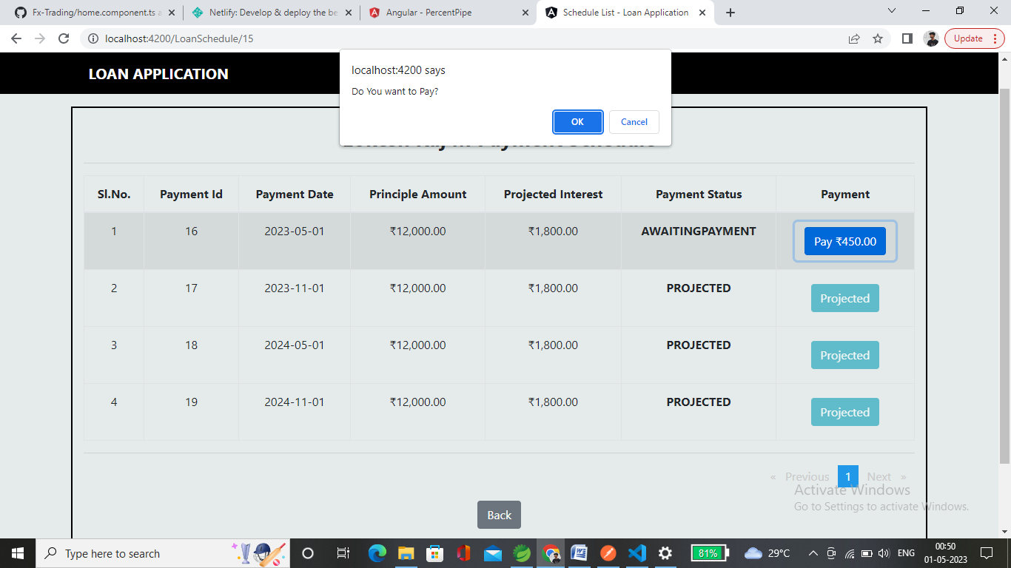

* 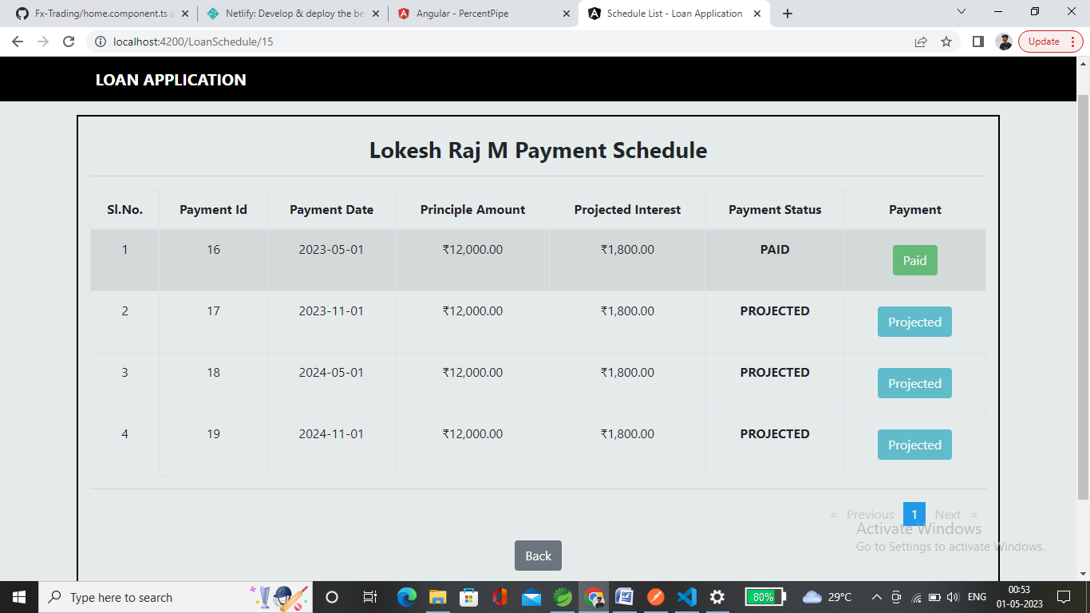While click the **pay** button it will show you the confirmation alert message once click ok payment status will change to **PAID**.
* It changes into **PAID** status.

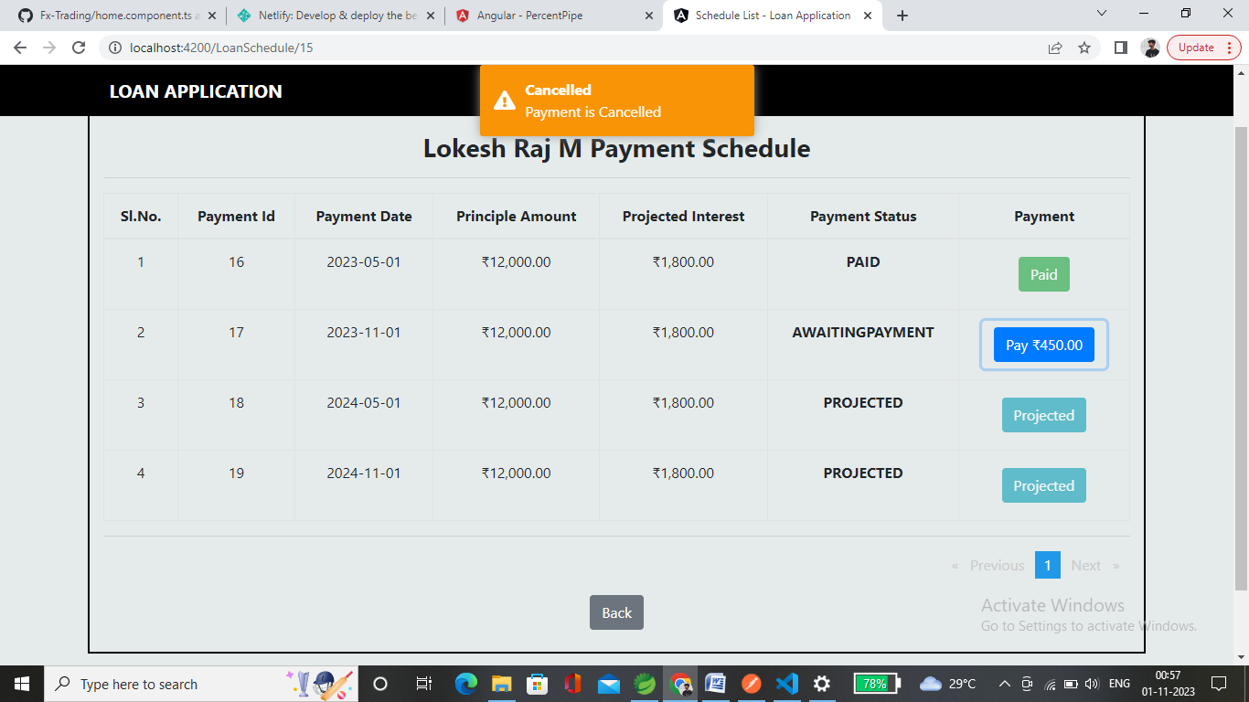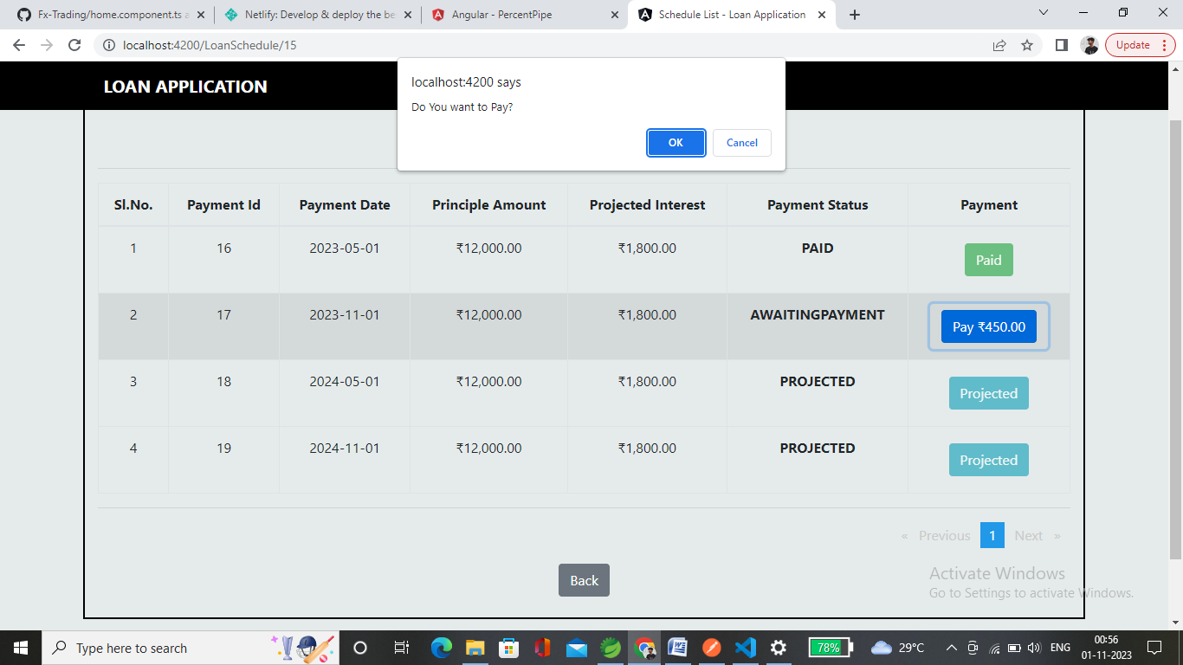

* On clicking on cancel it will cancel the payment.
* In a single page it shows 10 payment schedule.

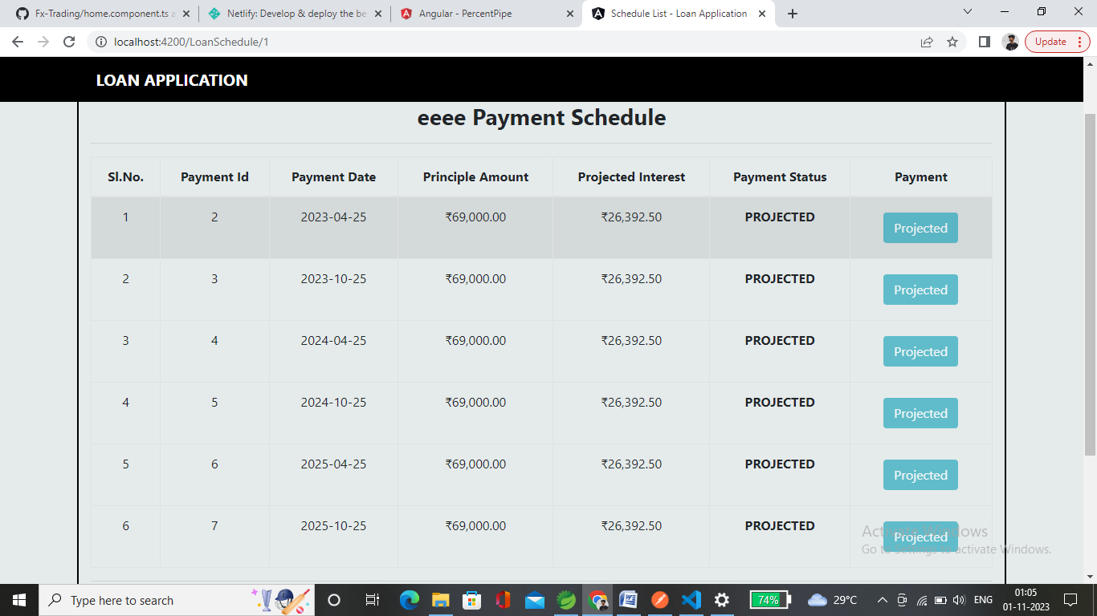**Interest Only:**

**Even Principal:**

